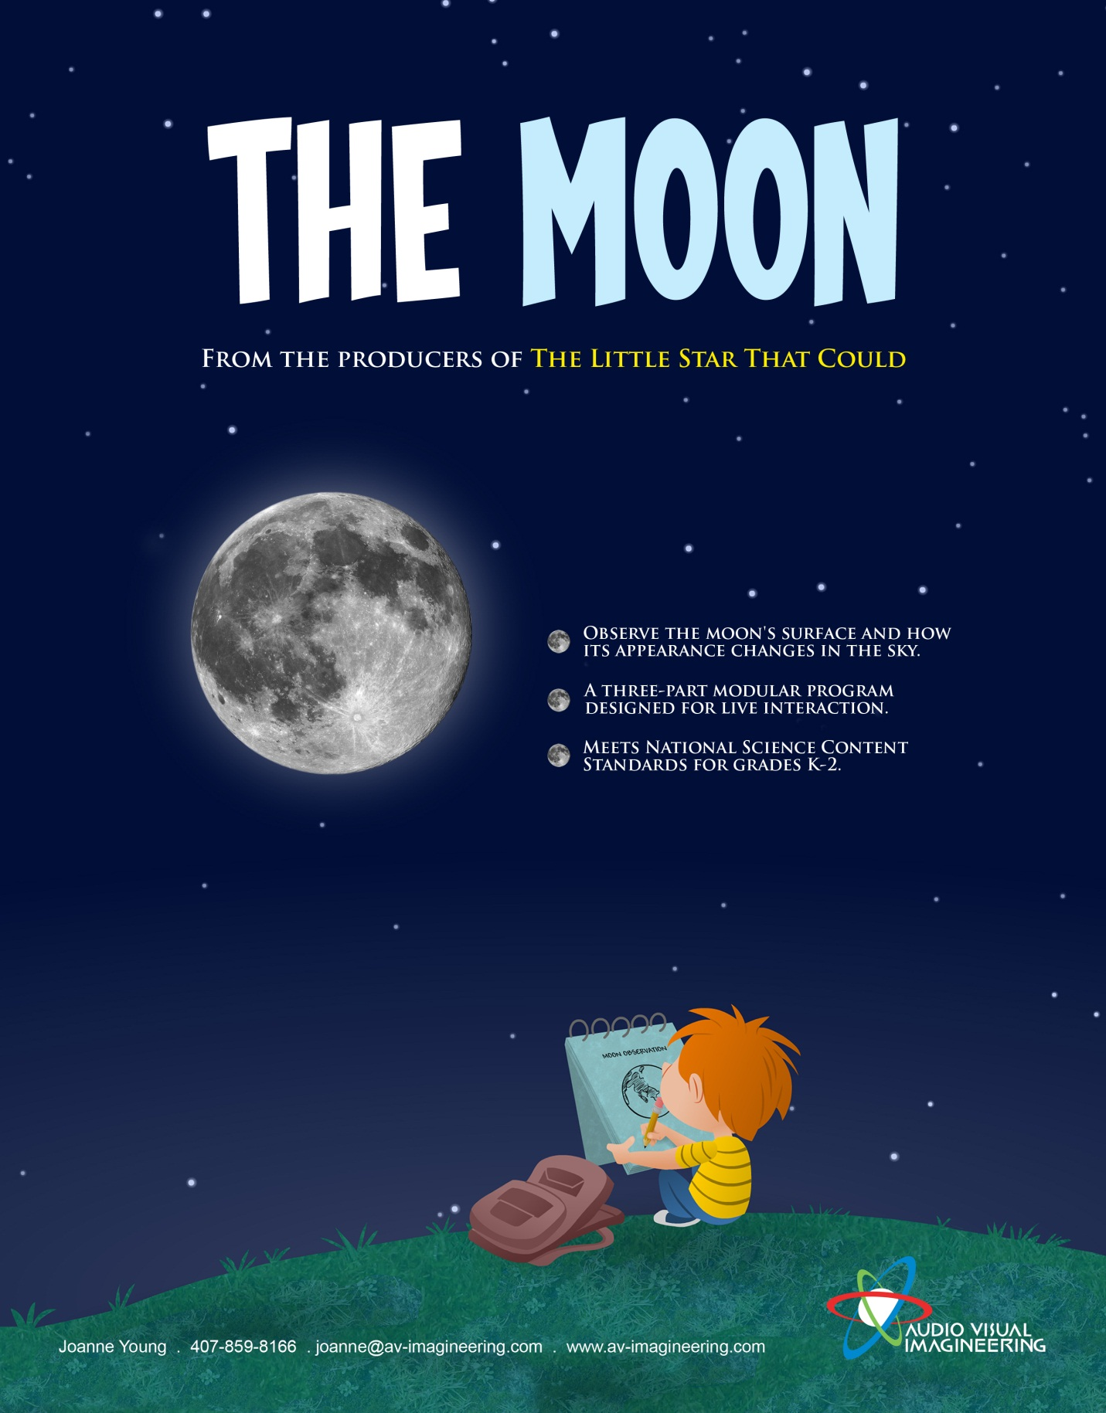
The Moon
A Modular Program

The following items are included with this product to provide a complete educational experience:
- The Moon fulldome modular planetarium program that is designed in three segments that can be paused in-between to allow for live interaction or to be played straight through without pauses.
- A list of standards and topics covered
- A suggested live interaction script (including a list of images and video clips).
- Images and video clips to be used during the live interaction pieces of the program.
- Pre and Post-planetarium lesson activities (Including PowerPoint docs).
- Program notes.

Science in the Dome Series
The Moon – Standards and Topics Covered
Recommended for Grades K – 2
National Standards Covered:
- Objects in the sky – The moon has properties, location, and movements that can be observed and described.
- Changes in earth and sky – Objects in the sky have patterns of movement. The moon moves across the sky on a daily basis much like the sun. The observable shape of the moon changes from day to day in a cycle that lasts about a month.
Topics Covered :
Properties of the moon that can be observed and described:
- The moon can be seen in the day or night sky.
- The moon looks like it is the same apparent size as the sun.
- When the moon is visible at night it is the largest and brightest object in the sky. This is because the moon is the closest natural object to the earth.
- The moon has darker areas that can be observed called maria. Maria means “seas”. At one time people believed these areas were covered with water like the seas on earth. These areas formed from ancient lunar lave flows.
- The moon has holes, called craters that can be observed. Craters are a result of the asteroid and meteorite impacts on the moon’s surface.
- The moon has highlands or mountain ranges that can be observed.
- The moon has no atmosphere. This allows the surface features of the moon to remain relatively the same over time.
- The same side of the moon always faces the earth. This is called the near side of the moon.
- The moon does not make its own light. The reason that we can see the moon is because it reflects sunlight.
- The moon’s appearance will look the same for any one day.

Location and movements (including patterns of movement) of the moon that can be observed and described:

- The moon rises and sets on a daily basis much like the sun.
- The moon rises toward the East at various times each day and sets toward the West at various times each day.
- The moon’s daily apparent motion is not a real motion. It is caused by the earth’s rotation.
- When the moon is observed each day at the same time over the course of a month it will move its location in the sky a little bit each day from West to East. This motion is due to the fact that the moon is orbiting the earth throughout the month.

The observable pattern of the moons appearance in the sky – moon phases:

- How the moon looks in the sky changes a little from day to day.
- The amount of moon that can be seen from earth is a phase of the moon.
- The moon phases have names: new moon, crescent moon, half moon, gibbous moon and full moon.
- The moon’s phase changes in a cyclic pattern over the course of 29 ½ days (about 1 month).
- The observable pattern of the moon’s appearance is predictable.

The Moon – Live Script
This program includes three separate automated modules. The modules cover the following topics:
- Module 1 – The observable features of the moon.
- Module 2 –The apparent daily motion of the moon.
- Module 3 – The pattern of change in the moon’s appearance (phases).
The program has been designed to be paused in-between each of the modules to allow for live interaction or to be played straight through.
Live interaction: A live interaction script and supporting visuals are provided to maximize the educational value of this program. The careful design of the live scripting content supports an increase in audience member’s content understanding and strengthens their abilities to engage in scientific practices in astronomy. The supporting visuals for the live interaction segments are designed to come in order as described in the live interaction script. For most systems, an operator would want to pause on each image to allow time for discussion. The scripting is provided as a suggested guide, however, presenters are encouraged to make their live segments their own and adjust the level based on the abilities of audience members.
Suggested Live Interaction Implementation:
- Prior to the running the automated Module 1, present Live Segment A, Compare the Earth to the Moon.
- After running Module 1 and prior to Module 2, present Live Segment B, Visit the Far Side of the Moon and present Live Segment C, The Apparent Motion of the Sun and Moon.
- After running Module 2 and prior to Module 3, present Live Segment D, Reviewing the Apparent Motion of the Sun and the Moon and present Live Segment E, Name the Phases of the Moon.
- After running Module 3, present Live Segment F, Review the Moon’s Motion in a Day Verse a Month.
Live Segment A – Compare the Earth to the Moon
Purpose – To introduce observable features of the moon
What is the closest object in space to the earth?  Answer: The moon  Let’s take a close look at the moon. What do you see?  Let’s take a close look at the earth. I want you to start to think about what you see and can learn by looking at these pictures. What is similar about the earth and the moon and what is different. Sometimes scientists ask these types of questions. They make observations and write them down to help them to remember.  What are some ways that the earth and the moon are similar?  Possible Answers: They are both round like a sphere, they both are moving in space, they both have land on them.  What are some of the ways that the earth and the moon are different?  Possible Answers: The earth is covered by a lot of water, the earth has clouds and an atmosphere, the earth has life on it and the moon does not, the moon is heavily cratered.  We are now going to watch a program that will help us learn more about the moon’s surface. See what new observations you can make by watching this program. | Show the image of the moon and the earth (Moon Show Image 1).  Play Module 1.

Live Segment B – Visit the Far Side of the Moon
Purpose – To introduce observable features of the moon
What did the little boy in the program learn about the moon by observing it?  Possible Answers: The moon has holes called craters, the moon has flatter areas called maria that are dried up lava flows, maria means seas but these are no seas on the moon, the moon has highlands, the moon has no weather, the moon surface stays the same all of the time.  What did the little boy do in the video to help him remember what the moon looked like?  Answer: He drew a picture in his notebook.  Scientists often draw pictures to help them remember and to show other scientists what they have learned.  What did the boy include in his sketch to help him learn about the moon’s surface?  Possible Answers: He drew arrows and labeled areas the different observable surface features of the moon.  What shape is the moon?  Answer: A sphere like a ball, not a circle.  How do we know that the moon is shaped like a ball or a sphere? Doesn’t it look kind of flat in the sky?  One way that we know that the moon is actually round is because spacecrafts, like the ones the astronauts rode to the moon, flew around the moon and saw what it looks like in space! They were able to take pictures of the other side of the moon, which helps us know that it is actually round, not flat.  The side of the moon that we see from earth (and have been viewing so far) is called the near side of the moon. Because the moon is actually a sphere, not a flat circle, there is a side of the moon’s “ball” that we do not see from earth called the far side of the moon. Do you want to see the far side of the moon? Let’s compare the near side to the far side of the moon by looking at a picture of both of them  Notice that the far side looks much different than the side of the moon that we see from earth.  How are they similar? (Encourage participants to use observable feature vocabulary that was presented in Module 1; i.e. maria, highlands, craters.  Possible Answers: Both similar colors, both have craters, both look rocky.  How are the different?  Possible Answers: The far side has more craters, the nearside has maria.  Now you can say you’ve seen the far side of the moon. | Show the image of the moon (Moon Show Image 2).  Point out the areas of the moon that the audience identifies.  Show the image of the boy’s un-labeled sketch of the moon (Moon Show Image 3).  Show the image of the boy’s labeled sketch of the moon (Moon Show Image 4).  Show the image of the moon (Moon Show Image 2).  Show the image of the moon with the “near side” label (Moon Show Image 5).  Show the image of the near side and the far side of the moon (Moon Show Image 6).

Live Segment C – The Apparent Motion of the Sun and Moon
Purpose – To introduce the apparent daily motion of the sun and moon.
Review the Cardinal Directions with the audience by having them point to East, South, West and North.  Who has seen the sun in the morning when it is first rising? Point to the direction you think the sun is in the morning. Everyone point at the sun.  Now, I want you to use your arms (by pointing) to show me what you think the sun is going to do if we watch it all day long.  We are going to watch more of the program soon and find out if your predictions about how the sun moves are correct. Scientists often make predictions and then make observations to help them find out if they were correct or if they need to change their ideas. Scientists change their ideas when their observations are different than what they originally thought.  What about the moon? Is the moon always in the same place in the sky? Have you ever seen it in different places?  It is important to pay attention to where we see objects in the sky to help us learn more about them. What do you think the little boy in the program we saw might do if he saw the moon in different places in the sky? If they don’t suggest drawing a picture ask, “do you think he would draw a picture of what he saw?”  Earlier you showed me what you think the sun does all day. Can you show me what you think the moon would do if you watched it all night by using your finger to point?  Now we are going to see how the moon appears to move throughout the sky in a single day. Imagine you were going to go outside and just watch the moon all day. Let’s see what you would observe. | Put Cardinal Directions on the dome  Image of the sun rising on the eastern horizon (Moon Show Image 7) or use planetarium sun.  Play Module 2.
Live Segment D – Reviewing the Apparent Motion of the Sun and Moon
Purpose – To review the apparent daily motion of the sun and the moon.
What did the boy in the program do to keep track of how the moon appears to move in the sky?  Answers: He followed it with his finger to trace its path, He drew a picture.  Right, he followed it with his finger and drew a picture that showed what he thought was important about the motion of the moon in one day.  Can you point to the direction in the sky that the sun and the moon rose?  Yes, toward the East.  Now, can you show me with your arms how the moon appears to move? (Trace the motion with them.) Remember that it takes the moon many hours to move all the way across the sky.  What direction does the moon set?  Answer: In the West.  What about the sun? Can you show me how the sun appears to move? Where does the sun rise and set?  Did you notice that the sun and the moon both rise in the East and set in the West. They both follow a similar path in the sky too.  Does anyone remember what was said in the program that makes the sun and the moon seem to rise and set? I will give you a hint, it has something to do with the Earth’s motions.  Answer: The Earth is rotating. The sun and the moon are not really moving as they appear to in a day. | Show the image of the boy pointing (Moon Show Image 8).  Show the image of the boy’s sketch showing the daily apparent motion of the moon (Moon Show Image 9).  Optional: Demonstrate the Earth’s rotation with a globe.
Live Segment E – Name the Phases of the Moon
Purpose – To introduce the phases of the moon
Materials: Moon phase labels for participants
Think about a time that you have seen the moon in the sky. What shape was it? Describe the shape.  Answers: A full circle, half moon, banana crescent shape, more than half but not quite full, no moon at all.  The way the moon appears in the sky is called the moon phases. Think of it as moon “faces”. These are all of the different ways that the moon shows itself to us on Earth.  Now we are going to match the moon phase names to the correct moon phase image.  Give the following clue: This moon phase is when we see half of the side of the moon that faces us on earth reflecting sunlight. It looks like a half circle. What we are really seeing from earth is one quarter of the moon’s sphere lit up so this is also called the quarter moon.  If you think you are holding the moon phase label for the type of moon I am describing go stand under (or in front of) that moon phase picture. (Point to the Quarter Moon.  Give the following clue: This moon phase is when we see the entire side of the moon that faces the earth lit up by the sun’s light. It looks like a whole circle.  If you think you are holding the moon phase label for the type of moon I am describing go stand under (or in front of) that moon phase picture.  Give the following clue: This moon phase is when we see none of the side of the moon that faces the earth lit up by sunlight.  If you think you are holding the moon phase label for the type of moon I am describing go stand under (or in front of) that moon phase picture.  Give the following clue: This moon phase is when we see less than half of the side of the moon that faces the earth reflecting sunlight. It can look like a little sliver or almost a half moon.  If you think you are holding the moon phase label for the type of moon I am describing go stand under (or in front of) that moon phase picture.  Give the following clue: This moon phase is when we see more than half of the side of the moon that faces the earth reflecting sunlight… but not quite a full moon. It can look a little bigger than a half circle all the way to an almost full circle.  If you think you are holding the moon phase label for the type of moon I am describing go stand under (or in front of) that moon phase picture.  These are the names of the moon phases. Together they represent all of the different moon phases.  Do you think we see the moon look like all of these different shapes every day?  Does the moon appear to change its phase in one day?  Let’s watch and see. | As each answer is given, put the images of the moon in different phases up to see. Continue until all of the moon phases are represented.  Hand out the moon phase labels. You could have one of each label represented or have everyone participate by making multiples of the same moon phase label.  The “Half/Quarter Moon” label people should stand under (or in front of) the Half/Quarter Moon image.  The “Full Moon” label people should stand under (or in front of) the Full Moon image.  The “New Moon” label people should stand under (or in front of) the New Moon image.  The “Crescent Moon” label people should stand under (or in front of) the Crescent Moon image.  The “Gibbous Moon” label people should stand under (or in front of) the Gibbous Moon image.  Play Module 3

Live Segment F – Review Moon’s Appearance in a Day vs. a Month
Purpose – To review the moon’s motions and appearances
We have seen that the way the moon looks in a single day is different from the way the moon looks in a single month.  Let’s watch the moon again in a single day and describe what it looks like.  How would you describe the moon’s appearance throughout a single day?  Answers: It stays in a single phase. It moves from East to West.  Remember how the boy reviewed this moon’s motion in a single day. He drew a picture of it.  Now let’s watch the moon again throughout an entire month.  How would you describe the moon’s appearance throughout the entire month?  Answers: It changes phases, It moves from West to East.  In fact the moon seemed to grow during the first half of the moon phase cycle. This is called a waxing moon. Then it seemed to get smaller during the second half of the moon phase cycle. This is called a waning moon.  It takes about 29 days (or about 1 month) for the moon to go through the entire moon phase cycle.  Remember in one day the moon phase is same, but throughout the month it changes from day-to-day. | Replay the moon moving throughout the day segment (Moon Motion Throughout a Day Video).  Show the image of the boy’s sketch showing the daily apparent motion of the moon (Moon Show Image 9).  Replay the moon moving throughout the month segment (Moon Motion Throughout a Month Video).  Show the image of the boy’s sketch of the waxing and waning moon phases (Moon Show Image 10).  Show the image of the boy’s sketch of the entire month phase cycle (Moon Show Image 11).
List of Images and Video Clips for Live Segments
Images
- Moon Show Image 1 – Image of the moon and the earth
- Moon Show Image 2 – Image of the moon
- Moon Show Image 3 - Image of the boy’s un-labeled sketch of the moon
- Moon Show Image 4 - Image of the boy’s labeled sketch of the moon
- Moon Show Image 5 – Image of the moon with the “near side” label
- Moon Show Image 6 – Image of the near side and the far side of the moon
- Moon Show Image 7 – Image of the sun rising on the eastern horizon
- Moon Show Image 8 – Image of the boy pointing
- Moon Show Image 9 – Image of the boy’s sketch showing the daily apparent motion of the moon
- Moon Show Image 10 - Image of the boy’s sketch of the waxing and waning moon phases
- Moon Show Image 11 – Image of the boy’s sketch of the entire month phase cycle

Additional Images
- Full Moon
- Gibbous Moon
- Quarter/Half Moon
- Crescent Moon
- New Moon

Video Clips
- Moon Motion Throughout a Day Video
- Moon Motion Throughout a Month Video

Pre-Planetarium Program Lesson
Materials:
- Picture window worksheets for daytime/nighttime drawings (included)
- Images of the day and night sky (Pre-visit PowerPoint included)

Lesson:
- Daytime Sky
“Today we’re going to start with investigating the question: What can we see in the daytime sky?” Each student receives a daytime/nighttime worksheet.

Pointing to the classroom window, say to the students: “Scientists sometimes answer their questions about the world by making observations. We are going to practice making observations to help us answer the question what can we see in the daytime sky? Let’s all go to the window and look around the sky. When you are done, return to your seat and draw a picture of all of the things you saw in the sky in the top box on your worksheet.”

“Now you can draw other things that you have seen in the daytime sky at other times that may not be out now.”

“We are now going to share what you drew. Who can tell me something that you have seen in the daytime sky?” Create a master copy of what the students saw in the daytime sky or have seen in the daytime sky. Try to clarify which things they saw when they looked out the window and which were other things they remember seeing in the daytime sky on other occasions.

“There may be other objects in the sky that we may not have thought of today. Let’s look at some photographs of the daytime sky and make more observations.” Show the additional photos (PowerPoint) of the daytime sky and add more ideas to the master copy of daytime objects. Ask, “Do you see anything else that is in the daytime sky that we have not included in our pictures yet”. As students answer, add them to the master copy and encourage students to add to their pictures.

- Nighttime Sky
What can we see in the nighttime sky?

“We can’t make any observations of the nighttime sky out the window right now, so draw what you can remember seeing in the night time sky before in the bottom box of the worksheet.”

“We will now share what you drew for the nighttime sky. Who can tell me something that you drew in your nighttime sky?” Create a master copy of what the students drew in their nighttime sky.
“Let’s look at other nighttime images (PowerPoint) to see if we have missed anything.” Go through the nighttime sky slides. Encourage students to add to their nighttime pictures. Add to the master copy as well.

- Extensions:
- Outer Space:
Engage students in a discussion of which objects in the sky are close to the earth and which are in outer space.

“Now I would like you to circle which of these objects in both the daytime and nighttime sky are in outer space. Can anyone tell me what they circled?” Model this on the master copy.

- Additional Points about the Moon

- Draw students’ attention to some of the features of their ideas in the chart. The sun is up during the day and not at night. The stars are up at night but not during the day. What about the moon? It is likely that some students have already said that the moon is up during the day and added that to the day time picture. Start the discussion by asking “How many of you have only seen the moon at night and not during the day? OK, and how many have seen the moon both during the day and during the night?”

Tell the students, “This is something that scientists do too. They sometimes disagree about their ideas. But they don’t just argue about it. They try to find evidence for to help them figure out whose idea is right.” Ask the students, “How do you think we could find out whether the moon can be up during the daytime or only at night?” (Hopefully there will be multiple ideas, including looking for the moon during the day.)

- “Earlier we saw pictures (PowerPoint night images) of the moon and the moon had different shapes (referring to nighttime images). What shape is the moon right now? How could we find out?”

- Show kids pictures of the moon (PowerPoint) and ask them if they have questions about the moon. Instead of answering them, tell them you are going to keep these questions until you see them again in the planetarium and then we’ll see if any of their questions have been answered.

Pre-visit Worksheet - Daytime vs. Nighttime
Draw things that you may see in the daytime sky in the top box and things that you may see in the nighttime sky in the bottom box.
Name ___________________
DAY

NIGHT

Post-Planetarium Program Lesson
Materials:
- Images from the planetarium program for reinforcement (Post-Visit PowerPoint included)

The following additional materials will be needed and are not included:
- Various photographs of the moon showing the surface of the moon
- Print-outs of the moon at different times of a single day (from a source such as Stellarium)
- Blank pieces of paper
- Print-outs of different phases of the moon
- Website for lunar phases

- Observable Features of the Moon
Give the children, in small groups, several pictures of the moon. Ask them “Which of these pictures help you understand what the ground on the moon is like?” Tell them they can choose as many of the pictures as they like.
Sharing: Show slide 1 on the Post-visit PowerPoint. After they look at the pictures, ask a group or a student which picture(s) they picked and why. Prompt them to talk about what they observed and what they noticed in the pictures that helped them know more about what the ground on the moon is like. Encourage them to use vocabulary terms for the moon’s surface features such as craters, maria and highlands.

- Path of the Moon
Give students (groups) the print-outs of the moon at different times of a single day/night. “I would like your group to put the images that you have of the moon throughout the day in order of how we would see them. After you have them in order I would like you to draw how this would look in the sky on a blank piece of paper.
Sharing: Show slide 2 on the Post-visit PowerPoint. Ask one of the groups to put their cards in order and share their drawing with the rest of the class. Discuss how the moon rises toward the East and sets toward the West.

- Phases of the Moon
Give the children, in groups, pictures of the different phases of the moon. Ask their teacher when his/her birthday is. Tell the children we are going to find out what the moon looked like a few days (3 days to 5 days) leading up to their teacher’s next birthday (using an online moon calendar). Show them the phase on the board. Ask the children to pick the phase that they think the moon will be in on their teacher’s next birthday using the pictures of the moon in their group. Each group can hold up their chosen phase.

Sharing: Call on one of the kids to explain why s/he picked that phase. Then go to the teacher’s birthday and see if they predicted correctly. “The moon will look like that all day and all night long on your teacher’s birthday. What do you think it will look like on the day after his/her birthday? Let’s find out.” Show the moon on the next day. Emphasize how it really looks almost the same and has only change a little bit. Continue for as many days as you would like. Show slide 3 and 4 on the Post-visit PowerPoint.

The Moon
Program Notes
Below are additional items that the planetarium presenter may want to discuss with the groups in the planetarium.
- Looking at the sun – In Module 1 the narrator mentions that it is unsafe to look directly at the sun (even with sun glasses on). However, participants and the main character in the program must look at the sun in order to follow the content of the program. Therefore, a discussion about solar viewing would be appropriate including an acknowledgement that the planetarium is not projecting the real sun and therefore it is safe to look at the planetarium sun.

- Lunar maria – In Module 1 the idea of lunar maria is presented. It is helpful to reinforce the fact that the lava flow on the moon is not from volcanoes like on earth. Further, the moon is no longer being bombarded at a high rate so few new craters or lunar surface features are being created now.

- Lunar phases – A discussion of the lunar cycle and the idea that the moon not only waxes but also wanes may be helpful. Studies show many children can demonstrate an understanding that the moon grows in size, however after a full moon they want to start the cycle over again with a new moon. Further discussion of this concept may be necessary.

- Observational astronomy – Since this program is designed for children in grades K through 2 emphases was put on what children can observe in the sky. To gain an understanding of what causes some of these observations may be beyond their understanding at an early age. For instance, explaining the causes of the moon phases can be difficult for young children who do not have the ability to think abstractly or spatially at this level yet. However, if appropriate these types of discussions could be added to these lessons as well.

